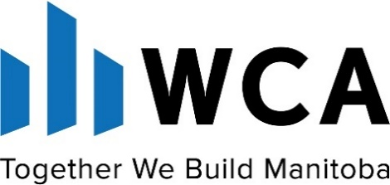

Annual General Meeting
February 18, 2026
Nomination Committee Report

As required under Section 11.4 of the General Bylaws, and in conjunction with Section 9.3, the Nomination Committee has developed a slate of nominees for the WCA Board of Directors ‐ one for each elected position ‐ and now gives notice that this slate (along with the Chairs elected by Divisions, Young Construction Leaders of Manitoba (YCLM), and Manitoba Women in Construction (MWC), will be presented at the 2026 Annual General Meeting for consideration and election.

Proposed Slate of Directors and Officers 2026:

Executive
Chair Peter Bernatsky, PSB Integration Inc. Manufacturer Supplier
Vice-Chair Teri Urban, Parkwest Projects Ltd. General Contractor
Treasurer Dom Costantini, BLDR Consulting Corporation Associate Member
Immediate Past Chair Roger Tuk, Rivers 3 Construction Ltd. General Contractor
President Ronald Hambley, WCA

Division Chairs (Elected by the Divisions)
Electrical Chris Dyck, Nor-Tec Group Electrical Contractor
Manufacturers Stacey Gagné, Signex Manufacturing Inc. Manufacturer Supplier Mechanical (MCAM) Julien Lafleche, ServcoCanada Mechanical Contractor
Trade Contractor Chris Precourt, Econo Wall & Ceilings Ltd. Trade Contractor
General Contractor Soo Lee, Bockstael Construction Limited General Contractor

Directors at Large (9 Members)
Shane Storie SRS Signs & Service, Inc. Manufacturer Supplier
Christopher Erbus Graham General Contractor
Craig Hildebrandt Westland Construction Ltd. General Contractor
Daniel Hartley Powertec Electric Inc. Electrical Contractor
Chris McRae PCL Constructors Canada Inc. General Contractor
Travis Paul Bird Construction Group General Contractor
Tara Kroeker Allco Electrical Ltd. Electrical Contractor
Nicholas Withoos M.D. Steele Construction Ltd. General Contractor
Zeb Hudon Penn-Co Construction Canada (2003) Ltd. General Contractor

Standing Committees:
Rich Marchetti (Transcona Roofing) - CSAM Advisory
Ben Robinson (M.D. Steele Construction Ltd.) - Young Construction Leaders of Manitoba Rep
Xuan (Sun) Nguyen (M Builds) - Manitoba Women in Construction Representative
John Schubert – Representative of the WCA Past Chairs Committee

The WCA Nomination Committee would like to thank all candidates who applied.

